Features of Fingerprints

Each person’s fingerprints are completely unique to them. Why, you might ask? Because each fingerprint has different **minutia** (min-ooh-she-uh), or features that define it.

C:\Users\seherbe\AppData\Local\Microsoft\Windows\Temporary Internet Files\Content.IE5\JWGKGCRL\MC900055181[1].wmf**KNOW** these terms before you enter the lab on Friday. Know what they mean, know how to describe them, know how to identify them, and know how to say them. We will use them from the beginning of class up until the end of your presentations in court.

* **Ridge ending** – the abrupt end of a ridge
* **Ridge bifurcation** (by-fer-cay-shun)– a single ridge that divides into two ridges
* **Short ridge, or independent ridge** – a ridge that commences, travels a short distance and then ends
* **Island** – a single small ridge inside a short ridge or ridge ending that is not connected to all other ridges
* **Ridge enclosure** – a single ridge that bifurcates and reunites shortly afterward to continue as a single ridge
* **Crossover or bridge** – a short ridge that runs between two parallel ridges
* **Delta** – a Y-shaped ridge meeting
* **Core** – a U-turn in the ridge pattern
* **Pore** – an opening in the skin, noticeable in a fingerprint by the presence of a white dot

**EXAMPLE PRINT**

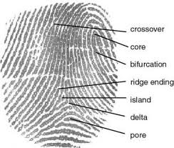

This *would* be a ridge enclosure if these two ridges came back together after the bifurcation

