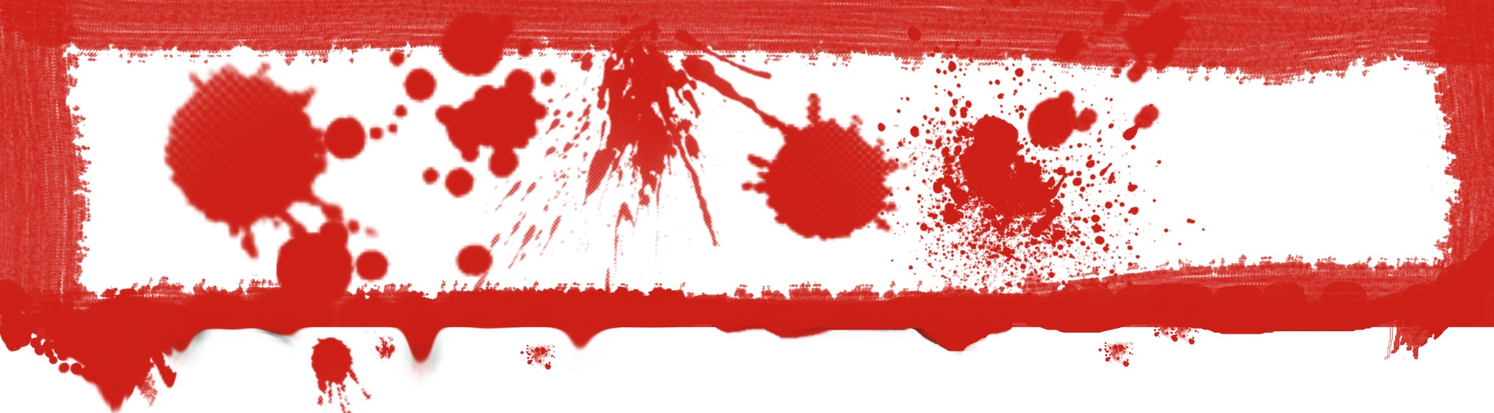
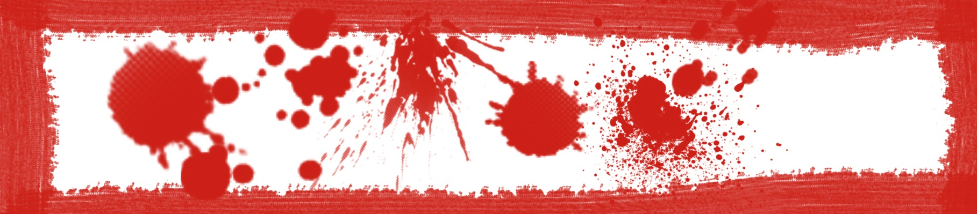
Blood Patterns
ALL of the Terminology:
Spatter – bloodstains created from the application of force or energy to the area where blood is
Target – the surface where the blood ends up
Origin – the point in space where the blood spatter came from
Parent Drop – the droplet from which satellite spatter originated (the main “big” droplet)
Spines – the pointed edges of a stain that radiate out to form the splatter
Satellite Spatters – small drops of blood that break off from the parent spatter when the parent droplet strikes a target surface.
Splash – pattern created when a volume of blood in excess of 1mL strikes a surface at a low to medium velocity (speed).
Swipe – the transfer of blood onto a target surface by a bloody object that is usually moving laterally (from side to side).
Wipe – pattern created when a secondary target moves through an existed wet blood stain on some other object
Arterial Spurt – large patterns created under pressure, but with less volume and usually more distinctive evidence of blood pressure rising and falling (with the beat of a heart).
Cast-Off Stains – blood that has been thrown from a secondary object (weapon or hand) onto a target other than the impact site.
More to Check Out
Look up more information on the “Blood” page at:
www.ubstem.weebly.com

