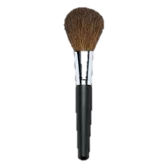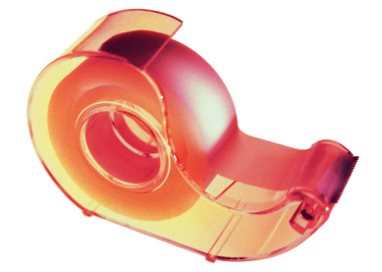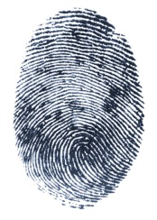Dusting for Prints

Step 1  
Preparing the Brush

1. Stretch the bristles of the brush apart.
2. Place a fair amount of dust powder on your brush by dabbing it in the powder.
3. Using gloves, place a piece of clear tape over the dusted print. If you’re working with a smooth surface, you can gently press down on the tape to remove bubbles
4. Place the tape on your black card.

Step 3:   
Lifting

1. Place the brush over the print. Lightly “twirl” the brush so that the powder dusts the print.
2. Blow the excess dust off of the fingerprint.

Dusting for Prints

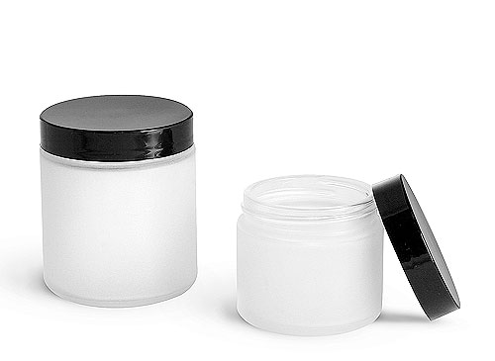

Step 2:   
Dusting



Congratulations!

You just lifted your first fingerprint! As small as you can (while still being able to read them) your initials on the back of your

fingerprint lift card.