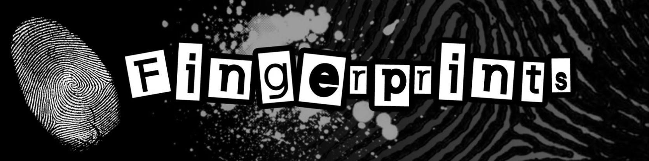

C:\Users\seherbe\AppData\Local\Microsoft\Windows\Temporary Internet Files\Content.IE5\JWGKGCRL\MC900055181[1].wmf

**Did you KNOW?** Fingerprints can be identified as one of nine different fingerprint types. Can you see the difference between the fingerprints below? Which type are your fingers? (You might have more than one!)

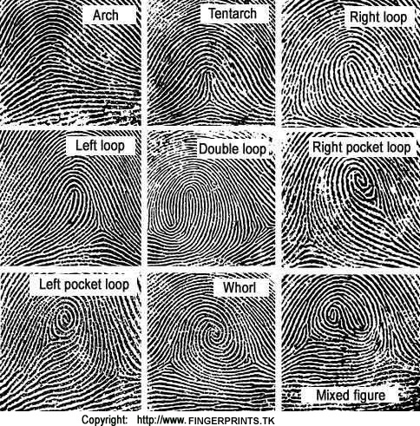

Unfortunately, many people have the same **types** of fingerprints – like the ones we just learned about. When it comes to discovering the difference between fingerprints in a case, the **minutia** (min-ooh-she-uh), or ridge features, are what would be used to match fingerprints. Some types of minutia are listed below:

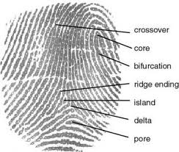

This *would* be a **ridge enclosure** if these two ridges came back together after the bifurcation

The more **minutia** you can find, the better the match is. In court, you would need at LEAST 12 matching points – referred to by specialists as a 12-point match – for the evidence to be considered. The more points matching, the more compelling the evidence.