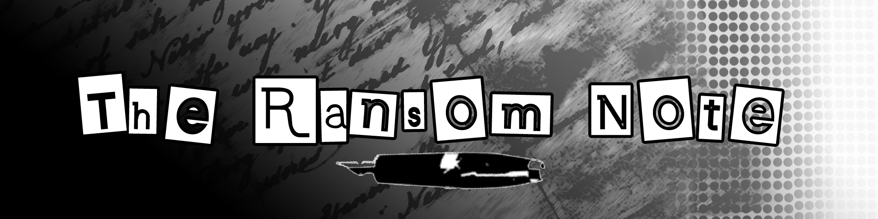

notes about notes
Think about every aspect of the note – what it’s made of, how it was made, who could have made it, etc. Write out as many ways as possible (shoot for at least twenty) to evaluate a note in order to find out who wrote it. You may use the internet to make your list if you run out of ideas.

