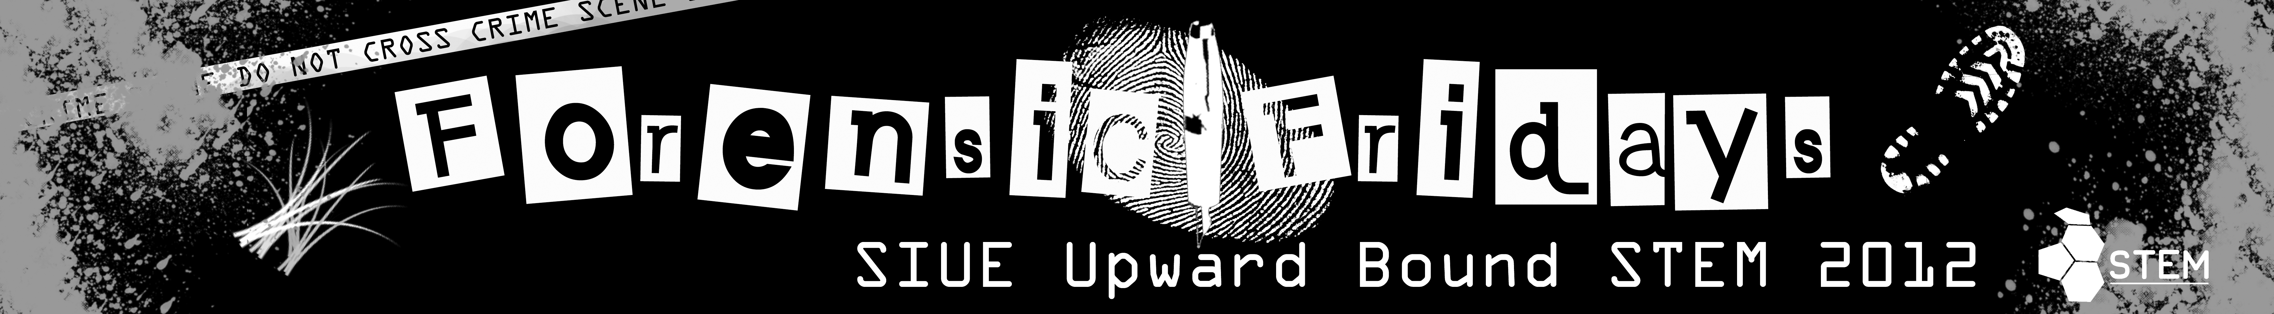

Presentation Rubric
CATEGORY | 4 | 3 | 2 | 1
Preparedness | Student is completely prepared and has obviously rehearsed. | Student seems pretty prepared but might have needed a couple more rehearsals. | The student is somewhat prepared, but it is clear that rehearsal was lacking. | Student does not seem at all prepared to present.
Comprehension | Student is able to accurately answer almost all questions posed by classmates about the topic. | Student is able to accurately answer most questions posed by classmates about the topic. | Student is able to accurately answer a few questions posed by classmates about the topic. | Student is unable to accurately answer questions posed by classmates about the topic.
Content | Shows a full understanding of the topic. | Shows a good understanding of the topic. | Shows a good understanding of parts of the topic. | Does not seem to understand the topic very well.
Speaks Clearly | Speaks clearly and distinctly all (100-95%) the time, and mispronounces no words. | Speaks clearly and distinctly all (100-95%) the time, but mispronounces one word. | Speaks clearly and distinctly most ( 94-85%) of the time. Mispronounces no more than one word. | Often mumbles or can not be understood OR mispronounces more than one word.
Visual Aid | Student uses visual aid effectively that show considerable work/creativity and which make the presentation better. | Student uses only mentions visual aid that shows considerable work/creativity and which make the presentation better. | Student uses visual aid ineffectively, or visual aid does not demonstrate work/creativity and adds little to presentation. | Visual aid not used, or not present.
Professionalism | Business attire, very professional look. Student speaks professionally at all times. | Casual business attire. Student speaks mostly professionally. | Casual business attire, but wore sneakers or seemed somewhat wrinkled. Speaks professionally at times. | General attire not appropriate for audience (jeans, t-shirt, shorts). Student does not speak professionally.

